**ARKANGEL**

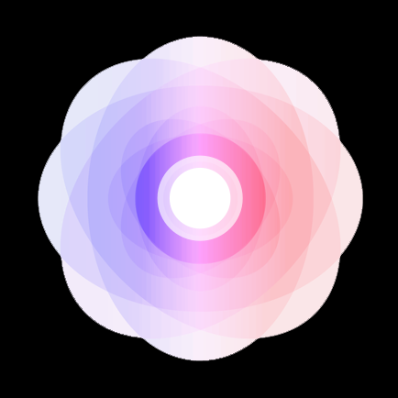

*A business plan submitted to Professor* *Alexander Kalil at BUSA 665-002*

Anjali Maria Dhanpal

Gull Zaib

Jyothi Meenakshi Ilangovan Rohini

Jyothirmai Kalava

Phani veera sai santosh kumar Devapati

Philip Wiredu Addo

Saadia Athar

Surya Kumar Devarajan

Jose Zea

Faculty of Management - McGill University

Montreal - April 2018

Copyright © April 2018

# EXECUTIVE SUMMARY

At Arkangel™ we believe extending human life lies in our hands. We have pioneered an exclusive Medical AI that eliminates the risk factors of chronical diseases without the use of drugs or invasive processes. Arkangel™ algorithm is housed in a mobile application free of download, and the structure of our program is built on top of 25-year of scientific research developed by the US Center for Diseases Control (National Diabetes Prevention Program, 2017).

Arkangel™ capitalizes on new trends of Data Science, Behavioral Science and Brain Plasticity to construct healthy habits that mitigate the generation of chronic diseases. Our proprietary software uses four main pillars to influence on people’s health: Sleep, Stress, Movement and Food; these four conditions have proved to influence 37% in health determinants (NEHI, 2013). Also, the rising popularity of off-the-shelf wearable technology and artificial intelligence makes this process promising. Our competitive advantage lies in our ability to merge technology and medical research to create an outcome-based business model that expands human life by destroying chronic diseases from its roots.

Our algorithm is ready to start working on the 7th leading cause of death in the US, Diabetes type II. Therefore, our early adopters will be users that are at high risk of Diabetes type II, also called pre-diabetes. We integrate a multi-channel sales approach that merges both a business to consumer strategy with our online payment method and a business to business strategy with governmental programs, private employers and insurances companies. On the operational side, we plan to start by focusing on the specific market mentioned and consequently expand Archangel’s algorithm to other markets and other chronic diseases like cancer and heart disease.

Our market size in US alone is a growing 84 million users already identified on pre-diabetes by the national diabetes report (Center for Disease Control, 2017). To start, we will focus on the largest concentration of diabetes type 2 diagnoses, the Southern Appalachian Area of the US. This strategy will target a modest 5% of the market size: 4.1 million users who have internet connection and a smartphone at the same time. Our pricing model compromises a US$2 per day fee paid yearly, and we recommend our users to stay for the 5-year risk period outlined by the CDC. Our success-based pricing model is proof of our inherent interest in reaching positive results. If a user gets diagnose with diabetes type II while on our program he will be fully refunded minus the administrative cost and taxes. To conclude, our financial strategy will use an initial $80,000 from co-founders to create an initial beta prototype for testing and reach a proof of concept. Once we get a solid proof of concept we will follow a seed funding of $500,000 from angel investors in exchange of 25% of company equity.

# TABLE OF CONTENT

ARKANGEL 1

EXECUTIVE SUMMARY 2

TABLE OF CONTENT 3

1 COMPANY 7

1.1 HISTORY 7

8

1.2 LEGAL AND CORPORATE STRUCTURE 9

1.3 VISION 11

1.4 MISSION 11

1.5 BUSINESS OBJECTIVES 14

1.6 COMPANY OWNERSHIP 15

2 MARKET ANALYSIS 15

2.1 MARKET OPPORTUNITY AND SIZES 15

3 COMPETITION 15

3.1 DIRECT COMPETITORS 15

4 PRODUCTS 15

4.1 DESCRIPTION 15

5 SERVICES 15

5.1 PURCHASING SUPPORT 15

6 SALES AND MARKETING 16

6.1 MARKETING STRATEGY 16

7 OPERATIONS 16

7.1 INFORMATIONAL TECHNOLOGIES 16

8 FINANCIAL PLAN 16

8.1 INCOME STATEMENT 16

9 EXIT STRATEGY 16

9.1 THE PROBLEM WITH THE CITY 16

APPENDIX A: SWOT ANALYSIS 17

APPENDIX B: BIBLIOGRAPHY 17

LIST OF FIGURES

Figure 0.1 NASA picture of North America at night showing the most populated areas. 5

Figure 1.1 Historical and projected evolution of Arkangel 6

Figure 1.2 Corporate structure of Arkangel 8

Figure 1.5 NEHI 2013 study shows the determinants of health in the human body vs the real expenditure of it in the US. The $2.6 trillion is 7.8 times the Canadian federal expenditure of 2017 (330.2 billion) (Boston University, 2016) 10

Figure 1.3 Trends that shape the future of healthcare by Dr Zayna Khayat at SU Germany Summit, 2017. 11

Figure 1.4 This graph illustrates the wonders of vaccination in the previous century helping us eliminate almost all viral diseases. Now the biggest threat to our health is our behaviour. (Boston University, 2016) 12

Figure 0.1 NASA picture of North America at night showing the most populated areas.

# COMPANY

## HISTORY

Arkangel™ was born in 2018 and has offices in Montreal, Canada and Bogotá, Colombia. We are a start-up that specializes in extending human life by preventing chronical diseases from happening. Our platform has a combination of data science, behavioural science and brain plasticity to influence in the user’s everyday habits and prevent chronic diseases from happening in the first place. In other words, we aim to kill the diseases before it happens without any drugs or invasive procedures and at a more competitive price if it is compare to the expenditures when sick.

The idea for this project was inspired by a personal event of one of the co-founders of the company were in a span of only four years his father and grandfather were diagnose with Parkinson Disease and Cancer respectively. Both diseases are categorized as chronical diseases because they last more than 6 months, they have no cure and they are progressive in time. As described by the physicians at the moment, both patients suffered from this event due to the accumulation of habits which led to the health problem. Thus, we recognized the pain in the market: a system that enabled people at high risk of getting a chronic disease to effectively prevent it from happening at an early stage. In addition, we decided to work solely on chronical diseases that have a proven scientific research and power it with technology to expand its success, so that our efforts could be massively adopted, peer-reviewed and clinically proven.

## 

Figure 1.1 Historical and projected evolution of Arkangel

## LEGAL AND CORPORATE STRUCTURE

We are a private start-up, structured as a limited liability corporation. Our team consist of twelve people, and it is comprised of world-class individuals who have joined to extend human life. We have the perfect combination of engineers, neuroscientists, doctors, and designers. We work seamlessly to reach our vision of eliminating chronic diseases from humans.

Our team is organized as follows:

1. Our Chief of People Officer - C.P.O. *Anjali Maria Dhanpal,* focuses on making sure that the team relies on perfect communication. She also makes sure that our clients are happy with the product by interacting with them and collecting feedback for us.
2. Our Chief Technology Officer - C.T.O. *Gull Zaib* is responsible for the existing technology, overseeing the development and keeping it up to the best standards.
3. Our Chief Financial Officer - C.F.O. *Jyothi Meenakshi Ilangovan Rohini* is responsible for the financial structure of Arkangel and keeps us running with enough resources.
4. Our VP Sales, *Jyothirmai Kalava* focuses on reaching to new clients at different scales. She also oversees communication with existing customers and creates strategies to develop specific sales forces.
5. Our Chief Operating Officer - C.O.O. *Phani veera sai santosh kumar Devapati* is responsible for all business operations, including operations management and research.
6. Our Chief Data Officer - C.D.O. *Philip Wiredu Addo* is responsible for the governance and utilization of information and data as assets, via data processing, data analysis, data mining, information trading, and other means.
7. Our Chief of Privacy and Regulatory Officer - C.P.R.O. *Saadia Athar* is responsible for all the privacy of the data in an Arkangel including privacy policy enforcement and HIPAA security compliances.
8. Our Chief Artificial Intelligence Officer - C.A.I.O. *Surya Kumar Devarajan* focuses on developing our main AI algorithm at Arkangel.
9. Our Chief Creative Officer - C.C.O. *Laura Velasquez* is responsible for the overall look and feel of marketing campaigns, media, and branding of Arkangel.
10. Our Chief Medical Officer - C.M.O. *M.D. Jose Elias Gomez* is responsible for scientific and medical research.
11. Our Chief Design Officer - C.D.O. *Paula Gomez* is responsible for product development. She also focuses on reaching the product development milestones.
12. 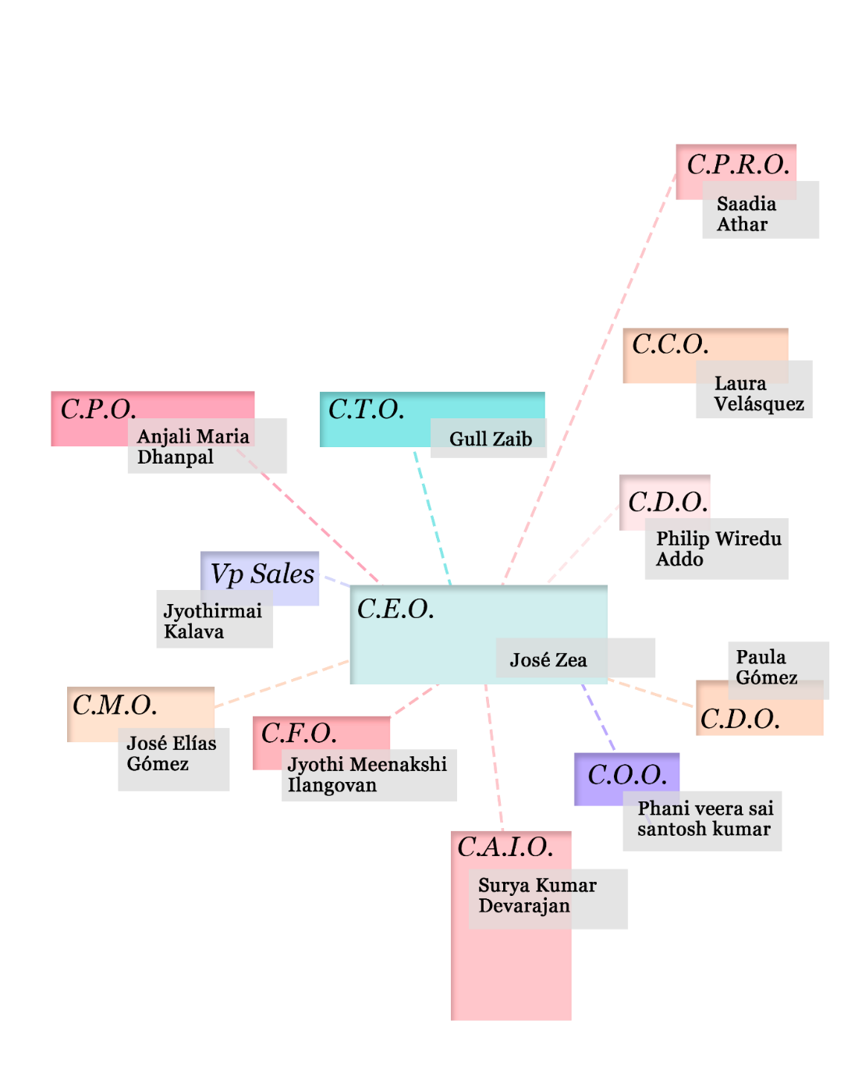Our Chief Executive Officer - C.E.O. *Jose Zea* is responsible for the overall vision and direction of Arkangel. He will answer to the board, and he will be responsible for any problem that the Company faces.

Figure 1.2 Corporate structure of Arkangel

## VISION

Our vision is to give the opportunity to people to extend their own lives by eliminating chronic diseases. The preventable healthcare market has been underestimated due to the difficulty of implementation. However, new advances in technology like of-the-shelf wearables and AI make it an opportunity to introduce it as part of the healthcare available. Our goal is to promote the use of tailor-made digital programs that adapt to the user behaviour and eliminates the behaviour-risk factors of getting a chronic disease.

## MISSION

The mission of Arkangel is to become a world-leading supplier of preventable health care in the digital era. We do this by creating products that disrupt the existing healthcare market by integrating new data science (AI) and off-the-shelf wearable technology, to help improve our client’s habits. These strategies are based on substantial medical-scientific research, and they advocate for a way to eliminate the source of the disease. We believe healthcare should be a holistic approach that integrates the full length of human life and not only the last part of it as shown in the diagram below.

*Today’s 90% expenditure of healthcare system US.*

Sick

*What about all of these people?*

Sick Death

Birth

Death

Birth

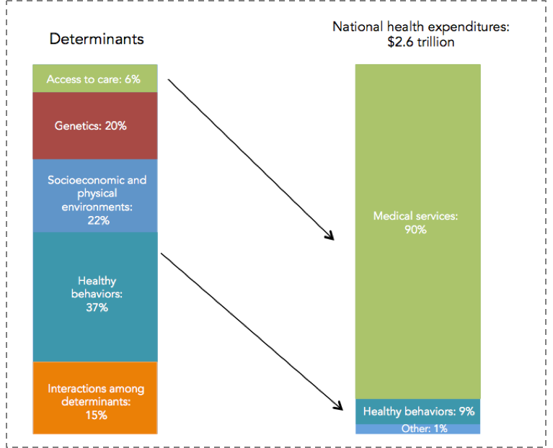

Figure 1.5 NEHI 2013 study shows the determinants of health in the human body vs the real expenditure of it in the US. The $2.6 trillion is 7.8 times the Canadian federal expenditure of 2017 (330.2 billion) (Boston University, 2016)

Our current efforts are geared towards the mitigation of diabetes type II through simple behaviour in four main pillars to influence on people’s health: Sleep, Stress, Movement and Food; these four conditions have proved to influence 37% in health determinants (see Figure 1.5). Last year more than 100 million adults in the U.S. alone were living with diabetes or prediabetes (Center for Disease Control, 2017).  Also, the average medical expenditures for people with diagnosed diabetes was about $13,700 per year. About $7,900 of this amount was attributed to diabetes (American Diabetes Association, 2013). This disease ranks on the top ten most common chronical diseases in the U.S, and it is the 7th leading cause of death killing directly 79.535 people a year (Center for Disease Control, 2017). If not treated, diabetes type II can lead to heart disease, stroke, vision loss, premature death, kidney failure, and it is the number one cause of lower limb amputation in the US. Under this circumstances, our algorithm is loaded with scientific standards from the CDC, psychological strategies and data science to create a system that effectively eliminates the risk factors for diabetes type II.

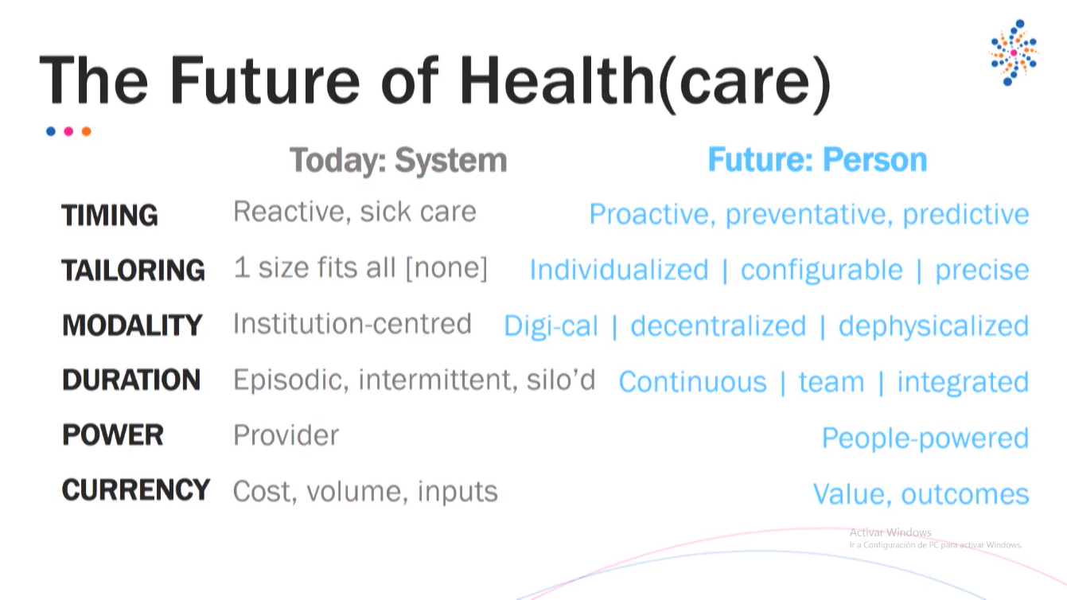Being in a digital format, it gives Arkangel an outstanding competitive advantage compare to traditional preventive programs given face-to-face because it lowers the costs of expansion and it allows for tailor-made programs based on current habits from the users detailed measure. Moreover, the information collected can be used to improve the performance of the technology and increase the outcomes over time. Arkangel ideals are in line with the future trends of healthcare outlined by Dr. Zayna Khayat at Singularity University by responding to all of them (See Figure 1.3).

Figure 1.3 Trends that shape the future of healthcare by Dr Zayna Khayat at SU Germany Summit, 2017.

Sourced from the presentation done by Dr Khayat. (Dr. Zayna Khayat, 2017)

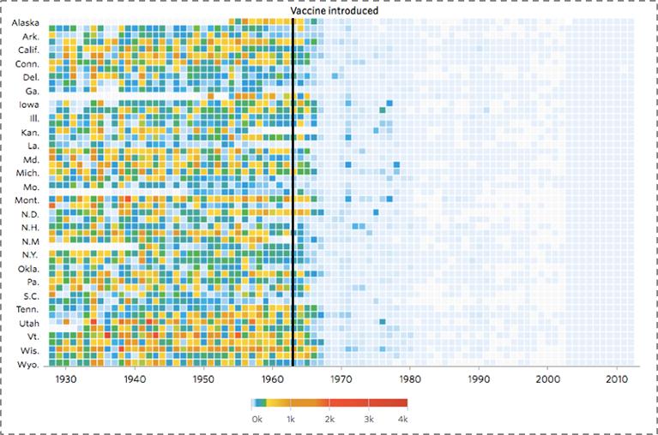

Figure 1.4 This graph illustrates the wonders of vaccination in the previous century helping us eliminate almost all viral diseases. Now the biggest threat to our health is our behaviour. (Boston University, 2016)

Our plans include the integration of more chronical diseases like Cancer, Alzheimer and Parkinson Disease, just to name a few. We believe that we are at the tipping point of a new type of healthcare system that disrupts the traditional and archaic one. In line with this thoughts, it is easy to visualize not only an expansion of Arkangel’s technology regarding diseases but also in new markets around the world like China and India

## BUSINESS OBJECTIVES

* In the short term, Arkangel plans to capture the market for prediabetes in the US and serve 5% of it: 1.2 million customers.
* Generate a yearly revenue from subscriptions of 876 million dollars by 2023 (at USD 730 a year per customer).
* Turn profitable after three years of operation.

## COMPANY OWNERSHIP

At the present moment, the company ownership is split equally at 8.3% between the 12 founding team members. All of them will fund the initial USD 80,000 product’s design phase equally in monetary terms and working hours. After the official launch in early 2019, the company will raise a seed capital of USD 500.000, and its co-founders will be diluted equally to meet the established 25% equity for the seed round agreed with investors.

# MARKET ANALYSIS

## MARKET OPPORTUNITY AND SIZES

# MARKET RESEARCH I

# DIABETES IN A NUTSHELL

*26-01-2018 – Source:* (Centers for Disease Control and Prevention, 2017)

The information below correspond to USA only:

* More than a 100 million Americans live with diabetes or pre-diabetes. It has no cure.

**Simple explanation:**

* Healthy levels of glucose: 60 – 99 ml
* Diabetic: +126 ml

2 main types:

F,{184bb0e7-a393-419a-876c-ce76b150d328}{118},6.0625,4.354167F,{184bb0e7-a393-419a-876c-ce76b150d328}{119},2.895833,0.6666667F,{184bb0e7-a393-419a-876c-ce76b150d328}{120},2.916667,0.6666667

F,{184bb0e7-a393-419a-876c-ce76b150d328}{123},7.229167,4.354167

If not controlled, it starts to affect the risk factor for:

1. F,{184bb0e7-a393-419a-876c-ce76b150d328}{152},5.229167,0.7291667F,{184bb0e7-a393-419a-876c-ce76b150d328}{153},2.770833,0.6666667F,{184bb0e7-a393-419a-876c-ce76b150d328}{154},0.6666667,0.6666667Heart disease
2. Stroke
3. Vision loss
4. Premature death
5. Kidney failure
6. Amputation of lower limbs
   1. Toes, feet, legs

F,{184bb0e7-a393-419a-876c-ce76b150d328}{217},10.10417,4.791667

## DIABETES IN NUMBERS:

* Diagnosed: 30.3 million (7.1 million have not being diagnosed yet.)
* Pre-diabetes: 84.1 million (1 in 3 americans)

## PRE-DIABETES FACTS:

1. Gender:
   1. 39.5% woman
   2. 44.5% man
   3. 16% not identified
2. Age (in years):
   1. 18-44: 27.4 million
   2. 45-64: 34.3 million
   3. 65-120: 23.1 million
3. Risk factors to develop it (percentage of patients diagnosed):
   1. Smoking: 15.9%
   2. Overweight and obesity: **87.5%**
   3. Physical inactivity: 40.8%
   4. High blood pressure: 73.6%
   5. High cholesterol (Hyperlipidemia): 66.9%
   6. High blood glucose (Hyperglycemia): 15.6%

## HOSPITALIZATION NUMBERS:

* 7.2 million Were hospitalize by diabetes.

***Reasons:***

1. Cardiovascular disease: 1’539.000 p
   * 1. Ischemic heart disease: 400.000 p
     2. Stroke: 251.000p
2. Amputation: 108.000p
3. Diabetes ketoacidosis: 168.000p

Note: Daily cost of hospital averages at $2.000

F,{752210b7-0aa6-45c8-bed5-7f0ede916626}{27},10.04167,6.020833

## DEATHS:

* 7th leading cause of death in USA (as 2015).
  + **79.535** death certificates with diabetes as leading cause.
  + **252.806** as side cause of death.
  + **332.341 total amount a year.**

## COST:

(American Diabetes Association, 2013)

* The total direct and indirect estimated cost of diagnosed diabetes in the United States in 2012 was $245 billion.
* Average medical expenditures for people with diagnosed diabetes were about $13,700 per year. About **$7,900** of this amount was attributed to diabetes.
* After adjusting for age group and sex, average medical expenditures among people with diagnosed diabetes were about 2.3 times higher than expenditures for people without diabetes.
* If pre-diabetes is not treated it can led to diabetes type 2 in only 5 years. (Most people don’t know they have prediabetes, only 11.6% know it)

## KEY STATS ON DIABETES AND PRE-DIABETES:

* The 84.1 million people on pre-diabetes can become a $639 billion expenditure for insurance and the government if not treated.
* 1 in 4 adults living with diabetes didn’t know they had the disease.
* Rates of population diagnosed:
  + American Indians / Alaska natives: 15.1%
  + Blacks (non-Hispanic): 12.7%
  + Hispanic: 12.1%
  + Asians: 8%
  + Whites: 7.4%
* Rates on education levels (from diagnosed people):
  + No high school diploma: 12.6%
  + High school diploma: 9.5%
  + More than high school diploma: 7.2%

F,{752210b7-0aa6-45c8-bed5-7f0ede916626}{156},6.833333,6.5

* The largest concentration of diabetes cases:

F,{752210b7-0aa6-45c8-bed5-7f0ede916626}{173},12.27083,5.625

F,{752210b7-0aa6-45c8-bed5-7f0ede916626}{178},8.541667,5.083333

Figure 0.1 Age-adjusted, county-level prevalence of diagnosed diabetes among adults aged +20 years, United States, 2013

The Figure 0.1 shows how the prevalence’s covers the zone known as the Southern Appalachian Area where the states of Mississippi and Alabama, Louisiana, Arkansas, Tennessee, Kentucky and Missouri are highly affected.

F,{752210b7-0aa6-45c8-bed5-7f0ede916626}{185},8.25,4.770833

Figure 0.2 Map of life expectancy at birth, Red 66.8yrs to Blue 86.8yrs, 2014. Source: vizhub.healthdata.org (University of Washington, 2018)

Similarly, Figure 0.2 shows the life expectancy in the same regions and it displays a decrease by 20 years in age from the county’s with the highest life expectancies and no risk of diabetes.

* As a side effect of creating programs to prevent pre-diabetes you can also prevent:
  + Heart disease 633.842p – 24% of deaths a year
  + Stroke 140.323p - 5.3% of deaths a year
  + Kidney 49.959p - 1.9% of deaths a year
  + Diabetes 79.535p - 3.0% of deaths a year
  + Vision loss
    - Total of people 903.659p - 34.2% of deaths a year

## COLOMBIA DIABETES FACTS:

Source: international Diabetes federation from the WHO

* 2nd country with most diabetic patients from South and Central America, after Brazil (Mexico in North America).
* 24.1 million Diagnosed with type 2 diabetes, and the WHO projects growth up to 38.5 million by 2035 (adults only).
* 22.4 people poses pre-diabetes in South and Central America.
* 2.1 million Diabetic patients in Colombia alone.
* Main reasons:
  + More people live in cities. Thus, more sedentary habits. Diabetes is also called the disease of the cities.
  + Dependence on the car
  + Little exercise
  + High calorie diets
* Deaths:
  + 226.000 in 2013 died from type 2 diabetes in the region.
* Costs (2013) from only diabetes in the region:
  + 26.3 thousand of millions COP (2013). *Not sure about the currency.*
  + 34.8 thousand of million COP (2035)

# MARKET RESEARCH II

# HEALTHCARE SYSTEM USA:

F,{46d47d31-d939-4256-9580-f67f15276e3c}{76},10.22917,10.52083

According to the World Health Organization (WHO), the United States spent more on health care per capita ($9,403), and more on health care as percentage of its GDP (17.1%), than any other nation in 2014 (WHO, 2014).

* The uninsured rate among U.S. adults was 11.9% for the first quarter of 2015 (Levy, 2015).
* The US remains the sole industrialized nation in the world without universal health care coverage (Fisher, 2012).
* From 2002 to 2008, 25% senior citizens declared bankruptcy due to health care expenses. 43% were forced to mortgage or sell their house. (Kelley, et al., 2012)
* A 2009 study in five states found that medical debt contributed to 46.2% of all personal bankruptcies and in 2007, 62.1% of filers for bankruptcies claimed high medical expenses (CBS, 2009)
* Over 27 million people in the US don’t have healthcare insurance coverage. The lack of health insurance is associated with increased mortality, about sixty thousand preventable deaths per year, depending on the study (Belluz, 2017).
* 39% of low income people refuse to go the health provider due to high prices.
* In 2015 the U.S. spent $3.2 trillion in personal healthcare
* Hospital stays in 2011 averaged 4.5 days and cost an average of $10,400 per stay (National Center for Health Statistics, 2016)

Cost of Health care broken down: F,{46d47d31-d939-4256-9580-f67f15276e3c}{139},8.854167,5.3125

## 85% of population has healthcare insurance:

* **59% through employer** or family/parent
  + Employer pays a bit of the insurance, shares with the employee. he/she negotiates the total price with the insurance company
* **28% under governmental programs**, covers:
  + Elderly
  + Disabled
  + Children
  + Veterans
  + Some low income population
* **9% individually bought**
* **4-11% uninsured** (varies)

*PPACA mandates that all buy health insurance

## Problems in the US healthcare system:

1. Doctors in the US are payed double the salary in Europe. This has led to high prices in the US healthcare system.
2. Doctors are payed for procedure and not by results. They are not incentivized on reaching a positive outcome.
3. There is not enough space for nurses, psychologist, therapists, pharmacists, etc. because everything needs to be supervised by doctors which increases the procedures price.

Main Source: Wikipedia (Healthcare in the US, 2018)

# MARKET RESEARCH III

# ANTIAGING INDUSTRY:

1. Supplements
2. F,{f2bac95a-b350-4035-98dc-e3086a4b157c}{22},6.208333,1.5Hormone replacement
3. F,{f2bac95a-b350-4035-98dc-e3086a4b157c}{32},0.6666667,0.6875F,{f2bac95a-b350-4035-98dc-e3086a4b157c}{33},0.9791667,2.229167Behavioral science and brain plasticity
4. Data science
5. Steam cells storage

Only the hormone replacement industry which slows or reverses the aging process generates a $50 billion industry (2009)

These create a system that predicts and create tailor made plans that extend human life.

Many parts of the body start to age and damage as the body ages.

* 122 is the longest a human has lived (registered), Jeanne Calmet.

1. Reasons for life expectancy:
   1. In a certain country average life space is lowered by child mortality, usually a sign of infectious diseases or nutrition
2. Aging – chronical diseases:
   1. Killed by accidents
   2. Chronical diseases due to age

**Possibilities in:**

1. Improved medical care
2. Vaccinations
3. Good diet
4. Exercise
5. Eliminating hazards like smoking

**Books:**

* “No more dying. The conquest of aging and the extension of human life” Joel Kurtzman (1976)
* “The life extension revolution” Saul Kent (1980)
* “Life extension: a practical scientific approach (1982)

**Consumer motivation:**

People buy these product to obtain:

* Hope for themselves
  + Their expectations success are the ones that dive their motivation.
* Avoid the feared-self (keeping youth skin and looking good)
  + People feel more motivated when the product fails because they seek to avoid aging at all cost.
* Ideal life spam is 91 years according to a survey.
* 38% want life extensions treatment, 56% don’t.
  + This is due to the fact that people believe that if they life longer they will life it in decrepitude or sick. Main Source: Wikipedia (Life Extension, 2018)

# MARKET RESEARCH IV

# CHRONIC DISEASES IN THE US

2017_Chronic disease report source: CDC

1. **What are they?**
   1. Ongoing, generally incurable diseases or conditions.
   2. Often preventable with early detection, improved diet, exercise, and treatment therapy
2. **What are the effects?**
   1. Chronically diseases are the leading cause of death and disability in the US
   2. 45% of the population have at least one chronic disease (133 million)
   3. Responsible for 7 out of 10 deaths in the US.
   4. Kills 1.7 million Americans a year.
   5. Can be disabling and debilitated the quality of life of people
      1. Every 30 seconds a lower limb is amputated as consequence of diabetes.
3. **Effects of the healthcare system**
   1. Patients under a chronic disease are the most frequent users of the health care
      1. 81% of hospital admissions
      2. 91% of all prescriptions filled
      3. 79% of all physician visits
   2. Account for the vast majority of health spending in the US (2 trillion: 2005 it is 3 trillion 2017- find the source)
   3. $5000 worth of spending per person on treatment with chronic disease (2005)
   4. Public funding programs accounts for 99% in medicare and 83% Medicaid.
4. **Effects of US Employers**
   1. Employers are paying high costs for chronic diseases through increase in health cost
   2. Healthcare premiums employer-sponsored family increased 87% from 2000 to 2005
   3. Health care coverage costs for people with chronic condition average $6032 annually, 5 times those without the chronic condition.
   4. Obesity cost private companies 13 billions annually.
      1. Includes the “extra” cost of health insurance (8 billion), sick leave (2.4 billion), life insurance (1.8 billion) disability insurance (1 million) all associated with obesity.
5. **The future effects:**
   1. Today’s situation is grave, but it is growing larger.
   2. By 2025 it will affect 49% Americans (164 million people) – half the population.
   3. Overweight rates keep climbing among children’s.
      1. 9 million (1 in 6 kids of age 6-19) were overweight in 2004. Triple the ammount of 1980
   4. Given current trends, one in 3 children’s will develop diabetes.
6. **Preventable problem**
   1. Many chronic diseases could be prevented, delayed or alleviated, through lifestyle changes
      1. The CDC estimates that eliminating 3 things like - poor diet, inactivity and smoking - we can prevent:
         1. 80% heart disease
         2. 80% stroke
         3. 80% type 2 diabetes
         4. 40% cancer.

For the f

# COMPETITION

## DIRECT COMPETITORS

For the f

# PRODUCTS

## DESCRIPTION

For the f

# SERVICES

## PURCHASING SUPPORT

For the f

# SALES AND MARKETING

## MARKETING STRATEGY

For the f

# OPERATIONS

The main goal of Arkangel™ is to prevent Type 2 diabetes thereby satisfying patient’s demands. Maintaining sufficient capacity to meet demand is one of the greatest challenges of operations management. Demand planning depends on some type of forecast. Here, the Type 2 diabetes and prediabetes forecasts are generated by analysing health habits of the individuals, and marketing and sales forecasts are based on current and expected future conditions**.** The goal of a forecast is to prepare the ways to meet the right amount of demand.

**15.1 INFORMATION TECHNOLOGIES**:

As we know Arkangel™ mainly focuses on three things.

1. Data science and Behavioural science
2. Artificial Intelligence
3. Smart wearables

F,{3f37c6ca-f085-4f42-81b4-1c1ce6ae6a10}{120},4.8125,3.458333 F,{3f37c6ca-f085-4f42-81b4-1c1ce6ae6a10}{121},5.583333,3.458333

We have a bunch of Data Scientists who are responsible for collecting the medical history of the people and analyse their historical background and create algorithms to predict their health in the future.

Our Computer Engineers involve in the development of software and mobile health coach (app) that uses artificial intelligence to prevent chronic disease from happening and can deliver effective interventions for at-risk diabetes patients.

We purchase smart wearables and develop self-optimizing algorithm to track and predict changes in steps walked, calories burned, sleep pattern, food intake.

Our advancing investments in machine learning and deep learning allow us to meet the high expectations of our customers. In this way, we can develop potential technologies to meet the needs. The competences of our workforce, the good adaptability and the performance of our product ensure compliance with the strict standards set by our customers.

**15.2 QUALITY:**

A quality control process is integrated into all parts of development, from collecting data, developing software, integrating our software into the smart wearables and inspecting them and getting the feedback from the patient’s usage. The main purpose of the quality check is that the end user should be prevented to develop diabetes based on his habits. The malfunctioning in any sector of the development life cycle will reflect in the life of the patients and a potential setback to the company. All the software development process should follow the guidelines of software quality assurance. We planned to develop an automated audit management that serve as a great source of information to delve deeper into data with predictive intelligence regarding safety and compliance.

F,{3f37c6ca-f085-4f42-81b4-1c1ce6ae6a10}{136},7,6.208333

**15.3 RESEARCH AND DEVELOPMENT:**

A wide variety of functions like heart rate, sleep pattern, number of steps walked etc, have been available through wristbands. In future we will expand to include blood glucose levels, pressure levels etc. Investment towards advancement in software and technologies should be taken into account to always stay ahead in the competition. Separate Multidisciplinary research teams integrated by computer scientists and doctors will be working together mirroring the need of cooperation and inventions in this new topic.

**15.4 SUPPLY CHAIN MANAGEMENT**:

It involves purchase of smart products, Real time computers, Intelligent Integrated Chips, Testing tools, Licences for readymade software tools and materials needed for office environment, security etc. The healthcare value chain is plagued with many problems, including outdated and inaccurate data, laborious manual processes, and lack of visibility into important information. We focus on design, research and development, planning, execution, control, and monitoring of supply chain activities with the objective of creating potential software for diagnosis of type 2 diabetes and in the same hand to get profitable successful outcome.

**15.5 FACILITIES**:

Arkangel™ has office in Montreal, Canada. The company has the adequate manpower and technical resources to cover lot of people and help in diagnosing the Type 2 diabetes and prediabetes. Arkangel™ will apply for incubation at the McGill Dobson Centre during the last three quarters of 2018 and will do the official launch in the early 2019. With increase in the customers and with higher success rates, we are planning to open further in major populated cxities.

**15.6 DEPARTMENTS AND HEAD COUNT:**

Arkangel™ has administration, management, legal, finance, marketing, sales, service, Research and Development, quality control and product development departments. We have a projection of 30 employees (excluding 9 of us in management) in total for the first year. The company's management philosophy will be based on responsibility and mutual respect. Arkangel™ will maintain an environment and structure that will encourage productivity and respect for customers and fellow employees. Additionally, the environment will encourage employees to have fun by allowing creative independence and providing challenges that are realistic and rewarding. The number of employees in each department is conditional to the business in the succeeding years. In future, these 30 employees will grow along with the business to management level and new employees will be recruited.

**15.7 CONTIGENCY PLANNING:**

To facilitate the timely response in the event of the disruption of the company’s normal business operation and services, Arkangel™ will be actively budgeted towards the contingency plans. It ensures the safety of the employees and resumption of the time sensitive activities in the case of any natural disaster, fire or blackouts. Whenever there is any change in the department, the policies and standards are revised to ensure the safety. It involves saving accurate and continuous vital records, data backup, off-site storage, Providing alternate sites for business operations. A proper coordination is to be maintained among the employees, vendors, and other internal and external individuals and organizations. Various steps are also taken to avoid Software Piracy.

# FINANCIAL PLAN

## INCOME STATEMENT

For the f

# EXIT STRATEGY

## THE PROBLEM WITH THE CITY

For the f

# APPENDIX A: SWOT ANALYSIS

# APPENDIX B: BIBLIOGRAPHY

American Diabetes Association. (2013). Economic costs of diabetes in the U.S. in 2012. *Diabetes Care*, pp. 36(4): 1033–1046.

Belluz, J. (2017, June 23). *Vox Media.* Retrieved from Vox: https://www.vox.com/policy-and-politics/2017/6/22/15857482/atul-gawande-gop-health-plan-bcra

CBS. (2009, June 5). *CBS News website.* Retrieved from https://www.cbsnews.com/news/medical-debt-huge-bankruptcy-culprit/

Center for Disease Control. (2017). *National Diabetes Statistics Report, 2017.* Retrieved from Center for Disease Control website: https://www.cdc.gov/diabetes/pdfs/data/statistics/national-diabetes-statistics-report.pdf

Center for Disease Control. (2017). *The Growing Crisis of Chronic Disease in the United States.* Atlanta: Center for Disease Control.

Center for Disease Control and Prevention. (2017). *National Diabetes Prevention Program.* Retrieved from Center for Disease Control and Prevention website: https://www.cdc.gov/diabetes/prevention/lifestyle-program/curriculum.html

Center for Disease Control and Prevention. (2017). *National Diabetes Statistics Report, 2017.* Atlanta: Center for Disease Control and Prevention, U.S. Dept of Health and Human Service.

Fisher, M. (2012, June 28). *The Atlantic.* Retrieved from The Atlantic: https://www.theatlantic.com/international/archive/2012/06/heres-a-map-of-the-countries-that-provide-universal-health-care-americas-still-not-on-it/259153/

Kelley, A., McGarry, K., Fahle, S., Marshall, S., Du, Q., & Skinner, J. (2012, September 8). Out-of-Pocket Spending in the Last Five Years of Life. *Journal of General Internal Medicine*, pp. 28 (2): 304–09.

Levy, J. (2015, April 13). *Gallup Well-Being.* Retrieved from Gallup : http://news.gallup.com/poll/182348/uninsured-rate-dips-first-quarter.aspx

National Center for Health Statistics. (2016, May 16). Retrieved from www.cdc.gov: https://www.cdc.gov/nchs/data/hus/hus15.pdf

NEHI. (2013). *Network for Excellence in Health Innovation.* Retrieved from Healthy People/Healthy Economy: An Initiative to Make Massachusetts the National Leader in Health and Wellness. 2015: http://www.tbf.org/tbf/56/hphe/Health-Crisis

Nichols, H. (2017, February 23). *The top 10 leading causes of death in the United States.* Retrieved from Medical News Today Website: https://www.medicalnewstoday.com/articles/282929.php

University of Washington. (2018, March 20). *Institute for health metrics and evaluation.* Retrieved from Viz Hub, US Health map: https://vizhub.healthdata.org/subnational/usa

WHO, W. H. (2014). *Global Health Expenditure Database.* Retrieved from Global Health Expenditure Database. Data Explorer.: http://apps.who.int/nha/database/Select/Indicators/en

Wikipedia. (2018, March 3). *Healthcare in the US.* Retrieved from Wikipedia: https://en.wikipedia.org/wiki/Health_care_in_the_United_States

Wikipedia. (2018, March 20). *Life Extension.* Retrieved from Wikipedia: https://en.wikipedia.org/wiki/Life_extension